

**St. Paul Institute Of Professional Studies**

**Indore (M.P.)**

Department of Computer Science

Project Report

On

“Gully sports”

Session 2017-18

A Project Report

Submitted in partial fulfilment of the

Requirements for the Graduate Degree in B.C.A.

Semester – VI

Guided By: Submitted By:

Prof. Gourav Rawal Ashay jain

(Head, Department Of Computer Science)

Under Taken For

Devi Ahilya Vishwavidyalaya , Indore(M.P.)



St. Paul Institute Of Professional Studies.

**PROFORMA FOR SUGGESTIONS OF BCA PROJECT POROPOSAL**

Enrollment No. : ……………………………

Study Centre:………………………………..

Regional Centre…………..….RCCode:……..……

E-mail:…………..……………………………

Telephone No.:…..……………………………

1. Name and Address of the student ………………………………………………………

2. Title of the Project ………………………………………………………………………

3 Name and Address of the Counsellor ……………………………………………………

4. Education Qualification of the Counsellor MCOM BCOM BCA BSc BBA

5. Working / Teaching experience of the Counsellor ……………………………………..

6. Software used in the Project ……………………………………………………………

Signature of Student

Date:……………….

Suggestions for improving the Project

Signature of Counsellor

Date:…………………..

**CERTIFICATE OF AUTHENTICATED WORK**

This is to certify that the project report entitled **Gully Sports** submitted to **St. Paul Institute Of Professional Studies, Indore** affiliated to **Devi Ahilya Vishwavidyalaya** in partial fulfilment of the requirement for the award of the degree of **BACHLORE OF COMPUTER APPLICATIONS (BCA)** is an original work carried out by **Mr. Ashay Jain** under my guidance. The matter embodied in this project is authentic and is genuine work done by the student and has not been submitted whether to this University or to any other University / Institute for the fulfilment of the requirement of any course of study.

**INTERNAL EXTERNAL**

**H.O.D PRINCIPAL**

**ACKNOWLEDGMENT**

I would like to avail this opportunity to express our sincere thanks to all those who helped us in making project a success.

My thanks to **Prof.GAURAV RAWAL** [Head of the Department Computer Science] Course Coordinator and Project Guide of **ST.** **PAUL INSTITUTE OF PROFESSIONAL STUDIES, INDORE** for assisting and providing us liberal encouragement not only during this project but throughout our studies at the College.

I wish to express our profound sense of gratitude to the Head and Faculty members of Computer Science Department of **ST.** **PAUL INSTITUTE OF PROFESSIONAL STUDIES, INDORE** who provided us constant motivation and inspiration throughout the Project, they provided best environment to study and facilities for the guidance all through BACHLORE OF COMPUTER APPLICATION (B.C.A.).

Lastly my thanks to my parents , colleagues and friends for their co-operation.

Ashay jain

**CONTENTS**

|  |  |  |
| --- | --- | --- |
| 1. | Abstract. | 6 |
| 2. | Introduction. | 7 |
| 3. | Survey of technologies. | 10 |
| 4. | Problem Domain | 12 |
| 5. | Solution Domain | 12 |
| 6. | Application Domain | 13 |
| 7. | Expected Outcome | 13 |
| 8. | System Specification | 14 |
| 9. | Software Description | 19 |
| 10. | Database Design | 21 |
| 11. | Sample Coding | 28 |
| 12. | Output | 80 |
| 13. | Testing | 87 |
| 14. | Bibliography | 93 |

**Abstract**

A web portal is a site that provides a single function via a webpage of site web portal often function as a point of access to information on the World Wide Web. Portals present information from diverse sources in a unified way.

Portal provide a way for enterprises to provide a consistent look and feel with access control and procedure for multiple application which otherwise would have been different entities altogether.

‘Gully Sports’ is a proposed project for providing a platform to a community of dog lovers and for the people who care about them. We intend to build a massive network so that trade of dogs become easy and leads to provide them a comfortable life. We support and promote a careful and free life.

**Introduction**

The ‘Dog INN’ is a web based recipe portal which efficiently handle the postings and rating related transaction made by its users i.e. admin, member and guests and is primarily meant for use on the net for net us

**Objective:**

The proposed project is a website for sports encouragement. The website showcase the user about the benefits of sports, importance of sports in their life why we should play any sports.

The website also showcases different sports with different clubs nearby them.

The website also showcases the safe measures while playing any sports, and it highlight why parents should push their child to play sports.

# **Achievements:**

By successfully implementing ‘GULLY SPORTS’, a substantial knowledge has been acquired on the implementation of dynamic web based database system using open source technologies. This knowledge will be useful in the future in creating any type of e-commerce application or online database systems in the web.

**SURVEY OF TECHNOLOGIES**

In a web based application like Online ‘Gully Sports’, there is scope for a large number of platforms, languages, web servers and frameworks to choose from. Before selecting from this large array of technologies, the following aspects, which are characteristic to a web based application like this one, have been kept in mind.

* Dynamic page generation
* Data validation
* Performance
* Reliability
* Scalability
* Portability
* Security
* Performance
* Time constraint
* Cost constraint

The various technologies available for consideration are as follows:

Client-side programming :-

1. HTML: HTML is used to create and save web document. E.g. Notepad.
2. CSS : (Cascading Style Sheets) Create attractive Layout.

**Problem Domain**

The problem is encountered when we find the homeless dogs and label them as stray instead of doing something for their concern of wellbeing. The major problem is dogs live miserable lives on roads. When a user has multiple options to explore on the very same platform, he/she has the choice to pick which is of their best interest. Hence a website is definitely a great need and great help.

**Solution Domain**

We propose a website to make this cumbersome task easy and provide user a platform where a large population can be gathered. And as per the concern over the miserable life of dogs, some solution can be figured out. Either an owner can give their dogs for dog care or report some street dogs over our platform for trading purpose or they can be taken care off.

**Application Domain**

The scope of the proposed project lies in complete interest of the user. They can run through the options available and prefer their choice of breed. Effective competitors in this field are Pawshake, Rover etc.

**Expected Outcome**

a.) Plethora of choices to the users.

b.) Platform to establish a community of dog caretakers.

c.) A site for Handy use.

d.) Help in price comparison.

**System Specification**

**Hardware Requirements:**

Processor : AMD E1-2100APU 1.00 GHZ

Clock speed : 500 MHZ

System bus : 32 bits

RAM : 4.15 M.B of RAM

HDD : 40 GB or higher

Monitor : Generic Pnp Monitor

Keyboard : 102keys

Mouse : 2 button mouse.

**Software Requirements:**

OS : WINDOWS 8

Front End : Notepad,

adobe dreamweaver cc 2018.

**Software Description**

**Xampp:**

**XAMPP** is a [free and open source](https://en.wikipedia.org/wiki/Free_software) [cross-platform](https://en.wikipedia.org/wiki/Cross-platform) [web server](https://en.wikipedia.org/wiki/Web_server) [solution stack](https://en.wikipedia.org/wiki/Solution_stack) package developed by Apache Friends, consisting mainly of the [Apache HTTP Server](https://en.wikipedia.org/wiki/Apache_HTTP_Server), [MariaDB](https://en.wikipedia.org/wiki/MariaDB) [database](https://en.wikipedia.org/wiki/Database), and [interpreters](https://en.wikipedia.org/wiki/Interpreter_(computing)) for scripts written in the [PHP](https://en.wikipedia.org/wiki/PHP) and [Perl](https://en.wikipedia.org/wiki/Perl) [programming languages](https://en.wikipedia.org/wiki/Programming_language).XAMPP stands for Cross-Platform (X), Apache (A), MariaDB (M), PHP (P) and Perl (P). It is a simple, lightweight Apache distribution that makes it extremely easy for developers to create a local web server for testing and deployment purposes. Everything needed to set up a web server – server application (Apache), database (MariaDB), and scripting language (PHP) – is included in an extractable file. XAMPP is also cross-platform, which means it works equally well on Linux, Mac and Windows. Since most actual web server deployments use the same components as XAMPP, it makes transitioning from a local test server to a live server extremely easy as well.

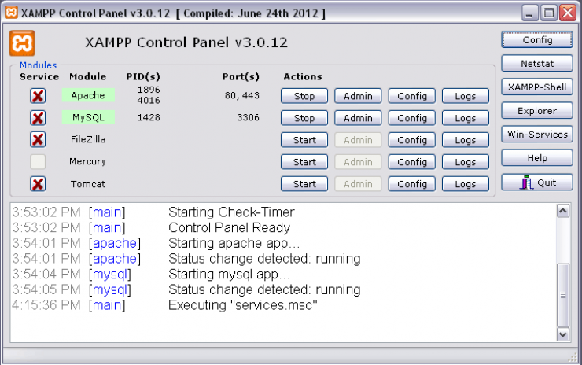

**Features:** XAMPP is regularly updated to the latest releases of [Apache](https://en.wikipedia.org/wiki/Apache_HTTP_Server), [MariaDB](https://en.wikipedia.org/wiki/MariaDB), [PHP](https://en.wikipedia.org/wiki/PHP) and [Perl](https://en.wikipedia.org/wiki/Perl). It also comes with a number of other modules including [OpenSSL](https://en.wikipedia.org/wiki/OpenSSL), [phpMyAdmin](https://en.wikipedia.org/wiki/PhpMyAdmin), [MediaWiki](https://en.wikipedia.org/wiki/MediaWiki), [Joomla](https://en.wikipedia.org/wiki/Joomla), [WordPress](https://en.wikipedia.org/wiki/WordPress) and more.Self-contained, multiple instances of XAMPP can exist on a single computer, and any given instance can be copied from one computer to another. XAMPP is offered in both a full and a standard version (Smaller version).

|  |  |  |  |
| --- | --- | --- | --- |
| **Component** | **On Windows** | **On Linux** | **On macOS** |
| Apache 2.4.29 | Yes | Yes | Yes |
| PHP | Yes - 7.2.3 | Yes - 7.2.3[[15]](https://en.wikipedia.org/wiki/XAMPP#cite_note-phpNixNote-15) | Yes - 7.2.3[[15]](https://en.wikipedia.org/wiki/XAMPP#cite_note-phpNixNote-15) |
| phpMyAdmin | Yes - 4.7.9 | Yes - 4.7.9 | Yes - 4.7.9 |

**NOTEPAD++**

**Notepad++** is a [text editor](https://en.wikipedia.org/wiki/Text_editor) and [source code editor](https://en.wikipedia.org/wiki/Source_code_editor) for use with [Microsoft Windows](https://en.wikipedia.org/wiki/Microsoft_Windows). It supports [tabbed](https://en.wikipedia.org/wiki/Tab_(GUI)) editing, which allows working with multiple open files in a single window. The project's name comes from the [C](https://en.wikipedia.org/wiki/C_(programming_language)) [increment operator](https://en.wikipedia.org/wiki/Increment_operator).

Notepad++ is distributed as [free software](https://en.wikipedia.org/wiki/Free_software). At first the project was hosted on [SourceForge.net](https://en.wikipedia.org/wiki/SourceForge.net), from where it has been downloaded over 28 million times, and twice won the SourceForge Community Choice Award for Best Developer Tool.The project was hosted on [TuxFamily](https://en.wikipedia.org/w/index.php?title=TuxFamily&action=edit&redlink=1) ([fr](https://fr.wikipedia.org/wiki/TuxFamily)) from 2010 to 2015; since 2015 Notepad++ has been hosted on [GitHub](https://en.wikipedia.org/wiki/GitHub).[[5]](https://en.wikipedia.org/wiki/Notepad%2B%2B#cite_note-5) Notepad++ uses the [Scintilla editor component](https://en.wikipedia.org/wiki/Scintilla_(software)).

**Features:** Notepad++ is a [source code editor](https://en.wikipedia.org/wiki/Source_code_editor). It features [syntax highlighting](https://en.wikipedia.org/wiki/Syntax_highlighting), [code folding](https://en.wikipedia.org/wiki/Code_folding) and limited [autocompletion](https://en.wikipedia.org/wiki/Autocompletion) for [programming](https://en.wikipedia.org/wiki/Programming_language), [scripting](https://en.wikipedia.org/wiki/Scripting_language), and [markup languages](https://en.wikipedia.org/wiki/Markup_language), but not [intelligent code completion](https://en.wikipedia.org/wiki/Intelligent_code_completion) or syntax checking. As such it may properly highlight code written in a supported schema but whether the syntax is internally sound or compilable cannot be verified. As of version 4.7.2,

The language list also displays two special-case items for ordinary [plain text](https://en.wikipedia.org/wiki/Plain_text): "Normal text" (default) or "MS-DOS Style", which tries to emulate DOS-era text editors.

Notepad++ has features for consuming and creating cross-platform plain text files. It recognizes three [newline representations](https://en.wikipedia.org/wiki/Newline#Representations) (CR, CR+LF and LF) and can convert between them on the fly. In addition, it supports reinterpreting plain text files in various [character encodings](https://en.wikipedia.org/wiki/Character_encoding) and can convert them to [ASCII](https://en.wikipedia.org/wiki/ASCII), [UTF-8](https://en.wikipedia.org/wiki/UTF-8) or [UCS-2](https://en.wikipedia.org/wiki/UCS-2). As such, it can fix plain text that seem gibberish only because [their character encoding is not properly detected](https://en.wikipedia.org/wiki/Bush_hid_the_facts).

Notepad++ also has features that improve plain text editing experience in general, such as:

* [Auto save](https://en.wikipedia.org/wiki/Autosave)
* Finding and replacing strings of text with [regular expressions](https://en.wikipedia.org/wiki/Regular_expression)
* Guided indentation
* Line bookmarking
* [Macros](https://en.wikipedia.org/wiki/Macro_(computer_science))
* [Simultaneous editing](https://en.wikipedia.org/wiki/Simultaneous_editing)
* [Split screen](https://en.wikipedia.org/wiki/Split_screen_(computer_graphics)) editing and synchronized scrolling
* Line operations, including sorting, case conversion (Uppercase, lowercase, camel case, sentence case), and removal of redundant whitespace
* [Tabbed document interface](https://en.wikipedia.org/wiki/Tabbed_document_interface)

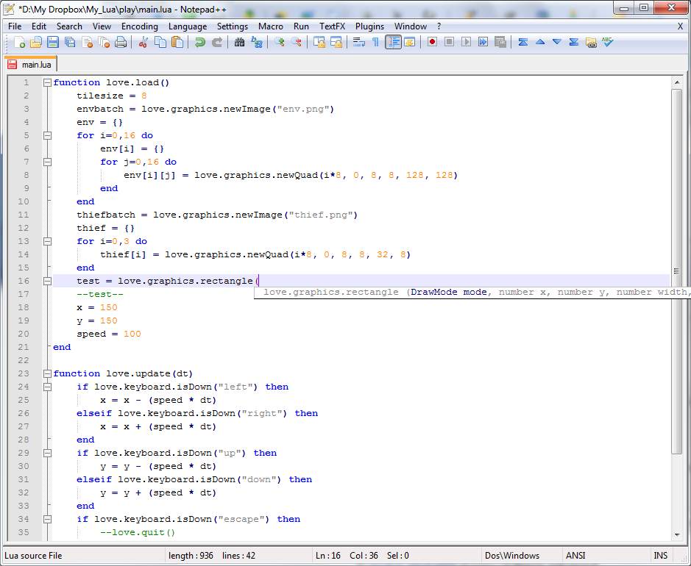

**DATABASE DESIGN**

The general theme behind a database is to handle information as an integrated whole. A database is a collection of interrelated data stored with minimum redundancy to serve many users quickly and effectively. After designing the input and output, the analyst must concentrate on database design or how data should be organized around user requirements. The general objective is to make information access, easy, quick, inexpensive and flexible for other users. During database design, the following objectives are concerned:-

* Controlled redundancy
* Easy to learn and use
* More information and low cost
* Accuracy
* Integrity

## **Data Integrity and Constraints**

Data integrity and constraints have been implemented in three stages- in the database level, in the server side code and in the client side. While the client side checks have been implemented using ASP.net in various forms, in the server side coding, check have been implemented to control the data that is sent in the database. However, most importantly, checks constraints have been implemented with in the SQL database in the following manner to ensure that data integrity is not violated.

**Table: User**

|  |  |  |  |  |
| --- | --- | --- | --- | --- |
| **Field** | **Type** | **Null** | **Default Value** | **Constraints** |
| User_ID | Int | No |  | Primary key |
| Username | Var[20] | No |  |  |
| password | Var[20] | No |  |  |

### Table: SignUp

|  |  |  |  |  |
| --- | --- | --- | --- | --- |
| **Field** | **Type** | **Null** | **Default Value** | **Constraints** |
| User_id | Text | No |  | Primary key |
| Name | Var[20] | No |  |  |
| Email | Var[30] | No |  |  |
| city | Var[20] | Yes |  |  |
| password | Var[20] | No |  |  |

### Table: Dog Details

|  |  |  |  |  |
| --- | --- | --- | --- | --- |
| **Field** | **Type** | **Null** | **Default Value** | **Constraints** |
| Dog Breed | Text | No |  |  |
| location | Text | No |  |  |
| Rate | number | Yes |  |  |
| image | Text | No |  |  |
| Health | Text | Yes |  |  |
| Date | Date | Yes |  |  |

***USER INTERFACE DESIGN***

The user interface of the ‘Dog INN’ transaction Management module is highly integrated with the user interface of the other two modules.

The following is the comment login interface for members, guest and admin

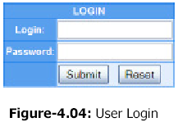

## **PROCEDURAL DESIGN**

### 4.3.1 Procedural Diagram

PROVIDE DETAILS

Submit the details

yes

yes

No

Book

A DOG

Book

Recipe/Article

POST

Recipe/Article

Select breed

Select

Become a sitter

Display availability

Login Member

No

logout

Show

availability

yes

No

Home page

**Sample Coding**

**Header.php**

<html>

<head>

<title>Dog INN</title>

<link href="css/minorfinal.css" rel="stylesheet" type="text/css" />

<link rel="stylesheet" href="font awesome\css\font-awesome.min.css" />

</head>

<body>

<div class="A">

<header>

<a href="minorf.php" class="logo"><i class="fa fa-paw"></i>Dog INN</a>

<span><a href="login.php" class="log"><i class="fa fa-user-o"></i><br/>LOG IN</a></span>

<span><a href="signup.php3" class="log"><i class="fa fa-user-o"></i><br/>SIGN UP</a></span>

<div class="clear"></div>

<div class="B">

<ul>

<b>

<li><a href="minorf.php" class="active">HOME</a></li>

<li><a href="about.php">ABOUT</a></li>

<li><a href="services.php">SERVICES</a></li>

<li><a href="availability.php">AVAILABILITY</a></li>

<li>

<a href="blog.php">BLOG</a>

</li>

</b>

</ul>

</div>

</header>

</div>

**Footer.php**

<footer>

<div>

<div class="f">

<h3>About DogINN</h3>

<ul>

<li><a href="ourstory.php" >Our story</a></li>

<li><a href="minorf.php" >Why DogINN</a></li>

<li><a href="blog.php">Blog</a></li>

<li><a href="about.php">Our Team</a></li>

</ul>

</div>

<div class="f">

<h3>OurCenters</h3>

<ul>

<li><a href="http://www.scoopyscrub.com/">Indore</a></li>

<li><a href="https://www.justdial.com/Dewas/The-Obeident-Pets-Near-navelty-square/9999P7272-7272-110122151510-F4F4_BZDET?xid=RGV3YXMgRG9nIFRyYWluaW5nIENlbnRyZXM=">Dewas</a></li>

<li><a href="">Ujjain</a></li>

<li><br></li>

</ul>

</div>

<div class="f">

<h3>Follow Us</h3>

<ul>

<li><a href="">Instagram</a></li>

<li><a href="">Google+</a></li>

<li><a href="">Twitter</a></li>

<li><br></li>

</ul>

</div>

</div>

</footer>

</body>

</html>

**Home.php**

**include ‘header.php’ ;**

<section id="one">

<p>Dogs are not our whole life, but they make our</br> lives whole.</p>

</section>

<section id="two">

<h1>Welcome to DogINN</h1>

<p>We are the trusted community for providing dog care services.Established in the year 2017, DogINN ,is a top player in the category pet shops in the cities like Ujjain ,Dewas & Indore. This well-known establishment acts as a one-stop destination servicing customers both local and from nearby locations. Over the course of its journey, this business has established a firm foothold in it’s industry. The belief that customer satisfaction is as important as their products and services, have helped this establishment garner a vast base of customers, which continues to grow by the day. This business employs individuals that are dedicated towards their respective roles and put in a lot of effort to achieve the common vision and larger goals of the company. In the near future, this business aims to expand its line of products and services and cater to a larger client base.It is known to provide top services in the following categories: Pet Shops, 24 hours veterinary doctors, Dog trainers at home etc.</p>

</section>

<section id="three">

<div >

<h1>We Treat Your Dog Like Family</h1>

<p>Home dog boarding | Dog walking | House sitting<p>

<div class="C">

<h3>Find</h3>

<img src="img/d6.png"/>

<p>Hundreds of petlovers offering their services.</p>

</div>

<div class="C">

<h3>Book</h3>

<img src="img/d3.jpg"/>

<p>Check availability, meet and greet and book online.</p>

</div>

<div class="C">

<h3>Relax</h3>

<img src="img/d5.jpg"/>

<p>Your pet enjoys a stay in a pet loving family.</p>

</div>

</div>

</section>

<section id="four">

<h1>Why DogInn</h1>

<div class="D">

<h3>Prime for the pet</h3>

<ul>

<li>Caring, personalized attention</li>

<li> No kennels, no cages</li>

<li>Stay locally in the community</li>

<li>Retain familiar items (bed, toys, treats, etc.)</li>

<li style="list-style-type:none"><br/></li>

</ul>

</div>

<div class="D">

<h3>Prime for you</h3>

<ul>

<li>No guilt: your animal is in loving hands</li>

<li>Daily photo updates</li>

<li>Easy online reservations</li>

<li>Safe and secure payments</li>

<li>Outstanding customer service</li>

</ul>

</div>

<div class="D">

<h3>Reliability</h3>

<ul>

<li>Vetted profiles</li>

<li>Transparent reviews</li>

<li>Open communication</li>

<li>Strong pet-loving community</li>

<li>Free Pet Insurance</li>

<br>

</ul></div></section>

include ‘footer.php’ ;

**About.php**

include ‘header.php’ ;

<section id="seven">

<h1>About</h1>

<p> Whether you need in-home dog boarding, pet sitting, dog walking, or day care, DogInn connects pet parents with dog people who’ll treat their pets like family.<br/><br/>

DogInn sitters are your rainy-day-dog-walkers.Your tug-of-war players. Your middle-of-the-night-caretakers. Because we get it—your dog is family. And when you can’t be there, you can trust us to keep your dog happy, healthy, and sweet as ever.<br/><br/>

But it’s not just about dog love.It's about the quality of love they recieve.DogInn is safe, easy, and affordable so that everyone can experience the unconditional love of a dog.<br/><br/>

So for the world travellers, the long-day-at-work, the business-trip jetsetters, the swing-shift survivors: We’re your people.<br/><br/>

Whatever you and your dog are into, we’re into it, too. And we’ve got your back. Anytime. Anywhere.<br/><br/>

</p>

<h6>At DogInn, every day revolves around dogs, and our office dogs are a key part of what makes coming to work so fun and rewarding. That's the #DogINNLife.

</section>

<section id="eight">

<h1>Our Team </h1>

<div class="L">

<div class="M">

<img src="img/prafful.jpg"/>

<h2>Prafful Patel</h2>

</div>

<div class="M">

<img src="img/bhavi.jpg"/>

<h2>Bhavana Mirchandani</h2>

</div>

<div class="M">

<img src="img/BB.jpg"/>

<h2>Shubham Namdev</h2>

</div>

</div><br/><br/>

<h5>

<a href="signup.php">Want to be a part of our community?</a>

</h5>

</section>

include ‘footer.php’ ;

**Service.php**

include ‘header.php’ ;

<section id="five">

<h1>Services We Offer</h1>

<div class="H">

<div class="E">

<img src="img/d7.jpg"/>

<h4>Dog Boarding</h4>

</div>

<div class="E">

<img src="img/d8.jpg"/>

<h4>Dog Sitting</h4>

</div>

<div class="E">

<img src="img/d10.jpg"/>

<h4>Dog Walking</h4>

</div>

</div>

<div class="I">

<div class="G">

<img src="img/d9.jpg"/>

<h4>Day Care</h4>

</div>

<div class="G">

<img src="img/d12.png"/>

<h4>Dog Minding</h4>

</div>

</div>

</section >

<div class="Z">

<a href="signup.php">Become a Sitter</a>

</div>

include ‘footer.php’ ;

**Availability.php**

**(before log in or sign up)**

**include ‘header.php’ ;**

<div style="text-align:center; padding:20px; margin:154px 100px ; border:2px dashed black; background-color:white; color:black; font-size:30px;" > TO SEE THE AVAILABILITY PLEASE LOGIN OR SIGNUP..!! </div>

**include ‘footer.php’ ;**

**(after log in or sign up)**

**include ‘header.php’ ;**

</div>

<div style="text-align:center; padding-top:30px; font-size:40px;"><b> DOGS AVAILABLE TO BOOK..!!</b> </div>

<section id="ten">

<div class="p">

<div class="q">

<div class="r">

<img src="img/dog4.jpg"/>

<h2> scooby </h2>

</div>

</div>

<div class="q">

<div class="r">

<img src="img/dog1.jpg"/>

<h2>Krypto</h2>

</div>

</div>

</div>

<div class="p">

<div class="q">

<div class="r">

<img src="img/dog2.jpg"/>

<h2> dodo </h2>

</div>

</div>

<div class="q">

<div class="r">

<img src="img/dog3.jpg"/>

<h2> coco </h2>

</div></div>

</div>

</section>

**include ‘footer.php’ ;**

**Blog.php**

**include ‘header.php’ ;**

<section id="nine">

<h1>Blog</h1>

<div class="O">

<div class="K">

<div class="N">

<img src="img/aditya.jpg"/>

</div>

<div class="N">

<h2>Aditya </h2>

<p>A great experience at DogINN.<br/>They really offer comforting amenities<br/> and make your dog feel home. </p></div>

</div>

<div class="K">

<div class="N">

<img src="img/dmg1.png"/></div>

<div class="N">

<h2>Krypto</h2>

<p>Best experience till date.Perfect place for dogs.Great care and a homely environment for them!!</p></div>

</div></div>

</section>

**include ‘footer.php’ ;**

**ourstory.php**

**include ‘header.php’ ;**

<section id="six">

<h1>OUR STORY<h1>

<p><b>Two Founders</b>with same passion and compassion of service towards dogs gathered and amalgamated their thoughts and came up with the idea of creating a platform to bring the dog lovers community over a click.The idea revolves around the fact of sympathy for the dogs and the willingness to be able to help them.<br/><br/>

Most street dogs experience brutal killing or they are left on their own to be cared of.<br/><br/>

wellbeing of pets and their owners. Yet, at the very heart of this project is the community itself: without its support and its suggestions, DogINN would never have seen the light of the day. Founders Vrashti and Shivali thank you for your interest and invite you to become a member of the DogINN community by signing up on the site.

</p>

</section>

**include ‘footer.php’ ;**

**Login.php**

<?php

if(isset($_POST['submit']))

{

session_start();

$_SESSION['usename']=$_POST['username'];

$_SESSION['userpassword']=$_POST['userpassword'];

$host="localhost";

$username="root";

$password="";

$db='logindetails';

$con= mysqli_connect($host,$username,$password,$db);

$sql="select * from details where username='".$_POST['username']."' and userpassword='".$_POST['userpassword']."'";

$result=mysqli_query($con,$sql);

$data=mysqli_fetch_assoc($result);

$z=mysqli_num_rows($result);

if($z==0)

{

echo 'invalid user';

}

else

{

}

}

?>

<html>

<head>

<title>Dog INN</title>

<style>

.getin{

width:40%;

margin:0px auto;

margin-top:60px;

border:2px solid black;

background-color:white;

}

.getin h1{

text-align:center;

padding-top:20px;

}

.getin form{

text-align:center;

padding:20px;

font-size:20px;

}

</style>

<link href="css/minorfinal.css" rel="stylesheet" type="text/css" />

<link rel="stylesheet" href="font awesome\css\font-awesome.min.css" />

</head>

<body>

<div class="A">

<header>

<a href="minorf.php" class="logo"><i class="fa fa-paw"></i>Dog INN</a>

<span><a href="login.php" class="log"><i class="fa fa-user-o"></i><br/>LOG IN</a></span>

<span><a href="signup.php" class="log"><i class="fa fa-user-o"></i><br/>SIGN UP</a></span>

<div class="clear"></div>

<div class="B">

<ul>

<b>

<li><a href="minorf.php" class="active">HOME</a></li>

<li><a href="about.php">ABOUT</a></li>

<li><a href="services.php">SERVICES</a></li>

<li><a href="availability.php">AVAILABILITY</a></li>

<li>

<a href="blog.php">BLOG</a>

</li>

</b>

</ul>

</div>

</header>

</div>

<div class="getin">

<h1>WELCOME USER</h1>

<form method="POST" action="" >

<label>USER ID:&nbsp;&nbsp;</label>

<input type="text" name="username" placeholder="ENTER YOUR USER ID">

<br>

<br>

<label>PASSWORD:&nbsp;&nbsp;</label>

<input type="password" name="userpassword" placeholder="ENTER YOUR PASSWORD">

<br>

<br>

<input class="button" type="submit" name="login" value="LOGIN">

<br>

<br>

<form method="post" action="signup.php">

<label>NEW USER:&nbsp;&nbsp;</label>

<input class="button" type="submit" name="signup" value="SIGNUP">

</form>

</div>

<footer>

<div>

<div class="f">

<h3>About DogINN</h3>

<ul>

<li><a href="ourstory.php" >Our story</a></li>

<li><a href="minorf.php" >Why DogINN</a></li>

<li><a href="blog.php">Blog</a></li>

<li><a href="about.php">Our Team</a></li>

</ul>

</div>

<div class="f">

<h3>OurCenters</h3>

<ul>

<li><a href="http://www.scoopyscrub.com/">Indore</a></li>

<li><a href="https://www.justdial.com/Dewas/The-Obeident-Pets-Near-navelty-square/9999P7272-7272-110122151510-F4F4_BZDET?xid=RGV3YXMgRG9nIFRyYWluaW5nIENlbnRyZXM=">Dewas</a></li>

<li><a href="">Ujjain</a></li>

<li><br></li>

</ul>

</div>

<div class="f">

<h3>Follow Us</h3>

<ul>

<li><a href="">Instagram</a></li>

<li><a href="">Google+</a></li>

<li><a href="">Twitter</a></li>

<li><br></li>

</ul>

</div>

</div>

</footer>

</body>

</html>

**Signup.php.**

<?php

if(isset($_POST['submit']))

{

$host="localhost";

$username="root";

$password="";

$db='logindetails';

$con= mysqli_connect($host,$username,$password,$db);

$a=$_POST['userid'];

$na=$_POST['name'];

$b=$_POST['usermail'];

$c=$_POST['userpassword'];

$d=$_POST['gender'];

$city=$_POST['city'];

$e=$_POST['phone'];

$insert="INSERT INTO details(`User_name`, `name`, `gender`, `email`, `password`, `city`, `phone_no`) VALUES('$a','$na','$d','$b','$c','$city',$e)";

if(mysqli_query($con,$insert))

{

echo 'USER REGISTERED';

}

else

{

echo 'NOT REGISTERED';

}

}

?>

<html>

<head>

<style>

form{

text-align:center;

font-size:20px;

border:2px solid black;

background-color:white;

width:60%;

margin: 0px auto;

padding:20px 0px;

margin-top:40px;

}

form h2{

padding-bottom:20px;

}

</style>

<link href="css/minorfinal.css" rel="stylesheet" type="text/css" />

<link rel="stylesheet" href="font awesome\css\font-awesome.min.css" />

<title>Dog INN</title>

</head>

<body>

<div class="A">

<header>

<a href="minorf.php" class="logo"><i class="fa fa-paw"></i>Dog INN</a>

<span><a href="login.php" class="log"><i class="fa fa-user-o"></i><br/>LOG IN</a></span>

<span><a href="signup.php" class="log"><i class="fa fa-user-o"></i><br/>SIGN UP</a></span>

<div class="clear"></div>

<div class="B">

<ul>

<b>

<li><a href="minorf.php" class="active">HOME</a></li>

<li><a href="about.php">ABOUT</a></li>

<li><a href="services.php">SERVICES</a></li>

<li><a href="availability.php">AVAILABILITY</a></li>

<li><a href="blog.php">BLOG</a></li>

</b>

</ul>

</header>

</div>

<form method="POST" action="">

<h2> PLEASE ENTER YOUR DETAILS TO SIGN IN: </h2>

<label>USER ID:&nbsp;&nbsp;</label>

<input width="300px"type="text" name="userid" placeholder="enter your unique username">

<br><br>

<label>NAME:&nbsp;&nbsp;</label>

<input type="text" width="300px" name="name" placeholder="enter your name">

<br><br>

<label>EMAIL:&nbsp;&nbsp;</label>

<input type="email" width="300px" name="usermail" placeholder="enter your email">

<br><br>

<label>PASSWORD:&nbsp;&nbsp;</label>

<input type="password" width="300px" name="userpassword" placeholder="enter unique password">

<br><br>

<label>GENDER:&nbsp;&nbsp;</label>

<label>MALE</label>

<input type="radio" name="gender" value="male">

<label>FEMALE</label>

<input type="radio" name="gender" value="female">

<br><br>

<label>ENTER YOUR CITY:&nbsp;&nbsp;</label>

<input type="text" name="city" width="300px" placeholder="enter your city">

<br><br>

<label>PHONE NUMBER:&nbsp;&nbsp;</label>

<input type="text" name="phone" width="300px" placeholder="enter your phone number">

<br><br>

<input type="submit" name="submit" value="submit">

</form>

<footer>

<div>

<div class="f">

<h3>About DogINN</h3>

<ul>

<li><a href="ourstory.php" >Our story</a></li>

<li><a href="minorf.php" >Why DogINN</a></li>

<li><a href="blog.php">Blog</a></li>

<li><a href="about.php">Our Team</a></li>

</ul>

</div>

<div class="f">

<h3>OurCenters</h3>

<ul>

<li><a href="http://www.scoopyscrub.com/">Indore</a></li>

<li><a href="https://www.justdial.com/Dewas/The-Obeident-Pets-Near-navelty-square/9999P7272-7272-110122151510-F4F4_BZDET?xid=RGV3YXMgRG9nIFRyYWluaW5nIENlbnRyZXM=">Dewas</a></li>

<li><a href="">Ujjain</a></li>

<li><br></li>

</ul>

</div>

<div class="f">

<h3>Follow Us</h3>

<ul>

<li><a href="">Instagram</a></li>

<li><a href="">Google+</a></li>

<li><a href="">Twitter</a></li>

<li><br></li>

</ul>

</div>

</div>

</footer>

</body>

</html>

**Minor.css**

*{

padding:0px;

margin: 0px;

}

body{

background-color:#f7f7f7;

}

.A {

position: relative;

padding-bottom:10px;

height:85px;

width: 100%;

padding-top:10px;

}

header{

position:fixed;

background-color:black;

width:100%;

height:90px;

top:0px;

}

.log{

float:right;

color:white;

text-decoration:none;

text-align:center;

margin-right:26px;

margin-top:9px;

font-family:'Comic Sans MS';

font-weight:20px;

}

.logo{

font-size:40px;

font-weight:200px;

padding-top:30px;

font-family:'Comic Sans MS';

padding-left:30px;

text-decoration:none;

color:white;

}

.clear{

clear:both;

}

.B{

position:fixed;

background-color: rgb(219,137,239);

margin-top:5px;

width: 100%;

}

.B ul{

height:30px;

width:80%;

margin:0px auto;

padding-top:1%;

}

.B ul li{

text-decoration:none;

display:inline-block;

margin:0px 70px;

}

.B ul li a{

text-decoration:none;

color:black;

font-weight:160px;

font-family:'Comic Sans MS';

}

.B ul li a:hover,.B ul li a.active:hover{

border-bottom:2px;

border-bottom-color:rgb(252, 227, 138);

border-bottom-style:solid;

}

#one{

background-image:url('images/d3.png');

background-repeat:no-repeat;

margin-top:-2px;

background-size:cover;

position:static;

height:722px;

}

#one p{

padding-top:40px;

font-size:50px;

text-align:center;

color:white;

}

#two{

width:80%;

margin:0px auto;

}

#two h1{

padding-top:40px;

text-align:center;

font-weight:400px;

font-size:50px;

}

#two p{

font-weight:160px;

padding-top:25px;

font-family:'Georgia';

font-size:20px;

text-align:justify;

}

#three {

width:80%;

margin:0px auto;

}

#three div{

margin-top:25px;

}

#three h1{

text-align:center;

font-size:40px;

font-weight:100px;

padding-top:30px;

}

#three p {

text-align:center;

font-size:30px;

font-weight:100px;

padding-top:20px;

color:gray;

}

.C {

display:inline-block;

width:32.64%;

background-color:white;

text-align:center;

font-size:20px;

padding-top:20px;

padding-bottom:20px;

}

.C h3 {

text-align:center;

padding-top:15px;

}

.C img{

width:200px;

height:250px;

padding-top:20px;

display:block;

margin-left:auto;

margin-right:auto;

}

#four{

width:80%;

margin:0px auto;

}

#four div{

margin-top:10px;

}

#four h1{

text-align:center;

font-size:40px;

font-weight:100px;

padding-top:52px;

}

.D{

display:inline-block;

width:31.64%;

text-decoration:none;

background-color:white;

text-align:center;

font-size:20px;

padding-top:20px;

padding-bottom:10px;

}

.D ul{

text-decoration:none;

}

.D ul li{

text-decoration:none;

padding-top:10px;

text-align:center justify;

margin-left:33px;

}

/* SERVICES */

#five{

padding-top:25px;

}

#five h1{

text-align:center;

font-size:40px;

padding-bottom:20px;

}

#five .H{

width:80%;

margin-left:150px;

}

#five .H .E{

width:32%;

display:inline-block;

border:1px solid #f7f7f7;

background-color:white;

}

.E img{

width:250px;

height:200px;

margin-left:auto;

margin-right:auto;

display:block;

padding-top:30px;

}

.E h4, .G h4{

text-align:center;

font-size:20px;

padding-top:10px;

color:gray;

padding-bottom:30px;

}

#five .I{

width:80%;

padding-top:40px;

margin:0px auto;

}

#five .I .G{

width:48%;

display:inline-block;

border:1px solid #f7f7f7;

background-color:white;

}

.G img{

width:250px;

height:200px;

margin-left:auto;

margin-right:auto;

display:block;

padding-top:30px;

}

.Z{

padding:50px 30px 0px;

font-size:30px;

text-align:center;

}

.Z a{

text-decoration:none;

background-color:rgb(219,137,239);

padding:10px;

color:white;

border:2px solid white;

}

/* OUR STORY */

#six{

padding-top:20px;

}

#six h1{

padding:20px 0px;

text-align:center;

font-weight:40px;

font-size:30px;

}

#six{

padding-top:10px;

font-size:20px;

padding-bottom:30px;

}

/* ABOUT */

#seven{

width:80%;

margin:0px auto;

}

#seven h1{

padding-top:72px;

text-align:center;

font-size:40px;

}

#seven h6{

padding-top:30px;

text-align:center;

font-size:32px;

color:gray;

}

#seven p{

text-align:center;

font-size:20px;

padding-top:30px;

}

#eight{

width:80%;

margin:0px auto;

position:static;

}

#eight h1{

padding-top:30px;

text-align:center;

font-size:40px;

}

#eight h6{

text-align:center;

width:100%;

margin:0px auto;

}

.L{

display:inline-block;

}

.M{

display:inline-block;

width:33%;

padding-top:30px;

height:350px;

background-color:white;

margin:0px auto;

}

#eight h5 a{

padding-top:10px;

text-decoration:none;

font-size:20px;

}

.M img{

width:260px;

height:260px;

padding:0px 56px;

display:block;

padding-top:30px;

position:static;

}

.M h2{

padding-top:20px;

text-align:center;

}

/* BLOG */

#nine{

width:80%;

margin:0px auto;

}

#nine h1{

text-align:center;

padding:20px 0px;

}

#nine .O .K{

display:inline-block;

}

.K{

width:48%;

border:1px solid #f7f7f7;

background-color:white;

}

#nine .O .K .N{

display:inline-block;

}

.N {

width:48%;

}

.N h2{

color:gray;

}

.N p{

font-size:20px;

}

.N img{

width:250px;

height:250px;

}

/*availablity AFTER LOG IN.............*/

#ten{

padding-top: 20px;

width:80%;

margin:0px auto;

}

#ten .p .q{

display:inline-block;

}

.p{

padding-top:40px;

}

.q{

width:48%;

border:1px solid #f7f7f7;

background-color:white;

}

.r {

width:48%;

padding-top:30px;

margin:0px auto;

}

.r h2{

color:gray;

}

.r img{

width:250px;

height:250px;

}

/*---------------contact_form------------------*/

.login{

padding-top:30px;

font-size:30px;

float:right;

margin-right:30px;

}

.login a{

text-decoration:none;

color:black;

}

.contact_form{

width:30%;

padding:30px 0px 40px 40px;

margin:55px 0 0 15px;

margin-left:450px;

border:1px #DFD1D2 dashed;

position:static;

}

.form_row{

width:335px;

clear:both;

padding:20px 0 20px 0;

color:#a53d17;

}

label.contact{

width:75px;

float:left;

font-size:12px;

text-align:right;

padding:4px 5px 0 0;

color: #333333;

}

input.contact_input{

width:253px;

height:18px;

background-color:#fff;

color:#999999;

border:1px #DFDFDF solid;

float:left;

}

textarea.contact_textarea{

width:253px;

height:120px;

font-family:Arial, Helvetica, sans-serif;

font-size:12px;

color: #999999;

background-color:#fff;

border:1px #DFDFDF solid;

float:left;

}

input.register{

width:71px;

height:25px;

border:none;

cursor:pointer;

text-align:center;

float:right;

color:#FFFFFF;

background:url(images/register_bt.gif) no-repeat center;

}

a.contact{

width:53px;

height:24px;

display:block;

float:right;

margin:0 0 0 10px;

background:url(images/contact_bt.gif) no-repeat center;

text-decoration:none;

text-align:center;

line-height:24px;

color:#fff;

}

/* FOOTER */

footer div .f{

display:inline-block;

width:33.08%;

margin:0px auto;

padding-top:20px;

text-align:justify;

}

footer div{

width:80%;

margin:0px auto;

}

footer{

margin-top:60px;

background-color:black;

color:white;

height:170px;

width:100%;

margin-bottom:0px;

}

.f ul{

padding-top:10px;

}

.f ul li{

display:block;

padding-top:5px;

}

.f ul li a{

text-decoration:none;

color:white;

}

**OUTPUT**

**Home page**

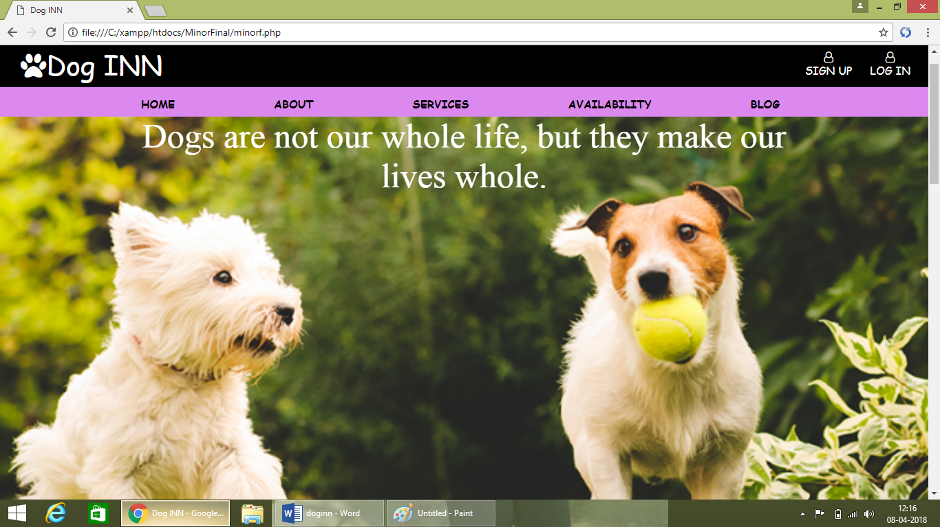

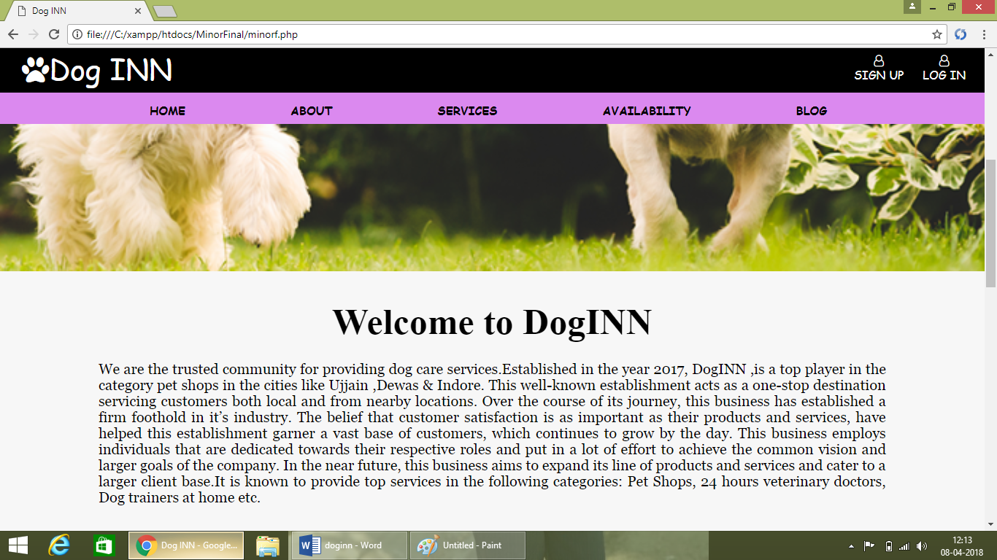

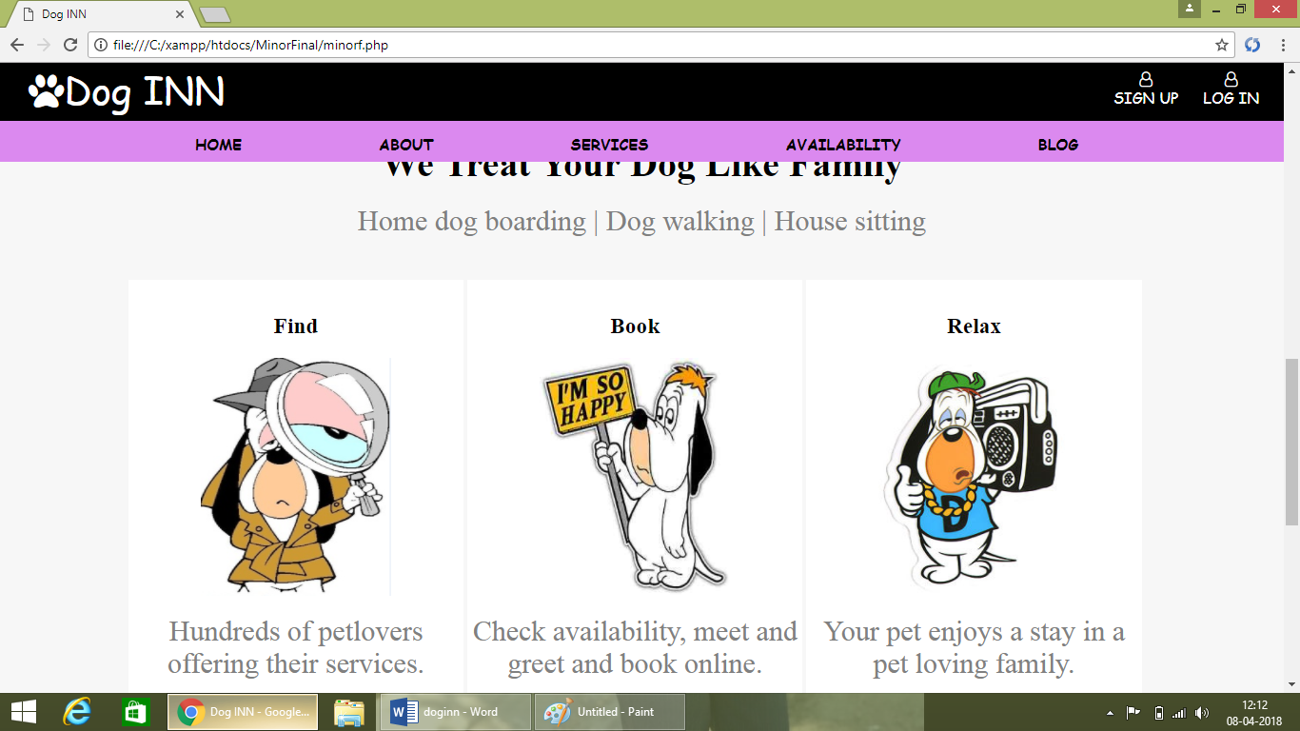

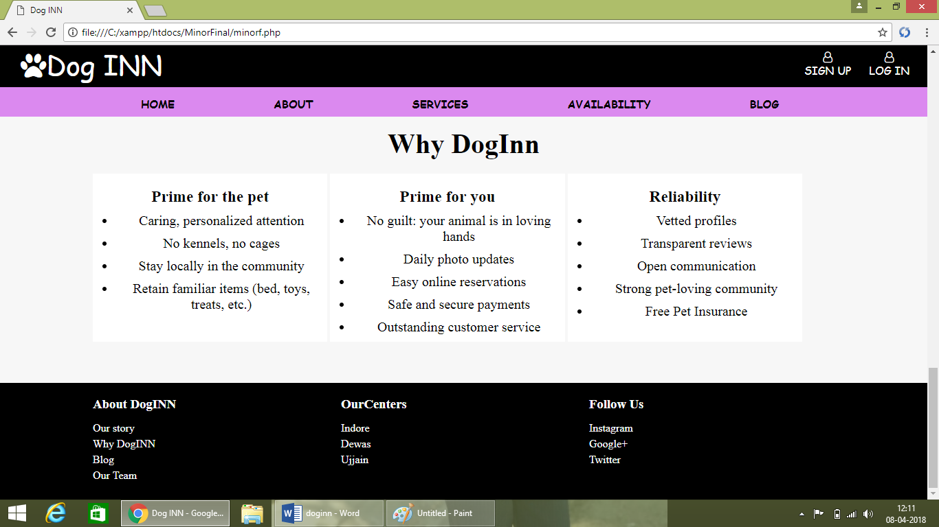

**About page**

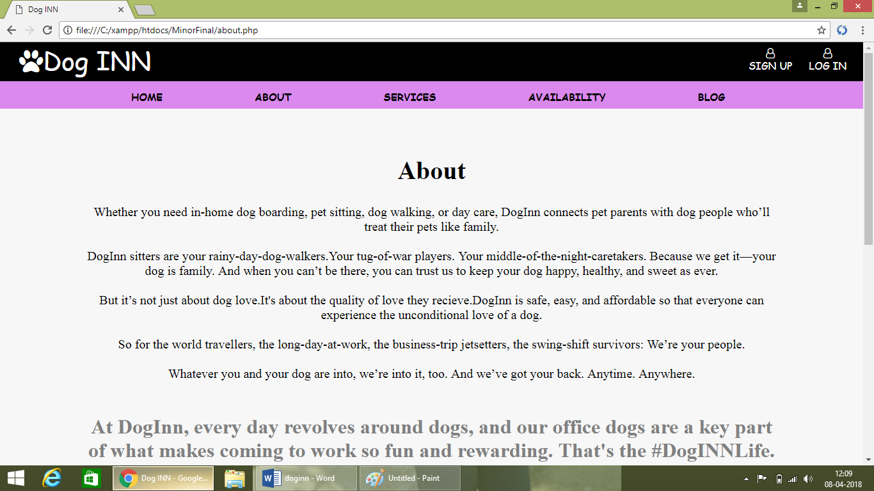

**Service page**

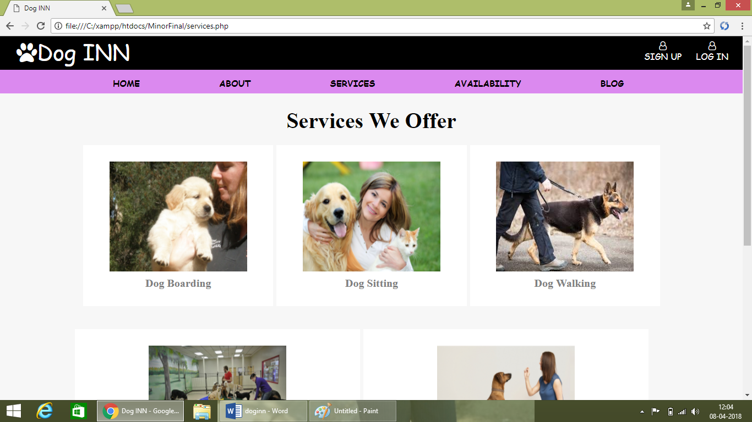

**Availability page**

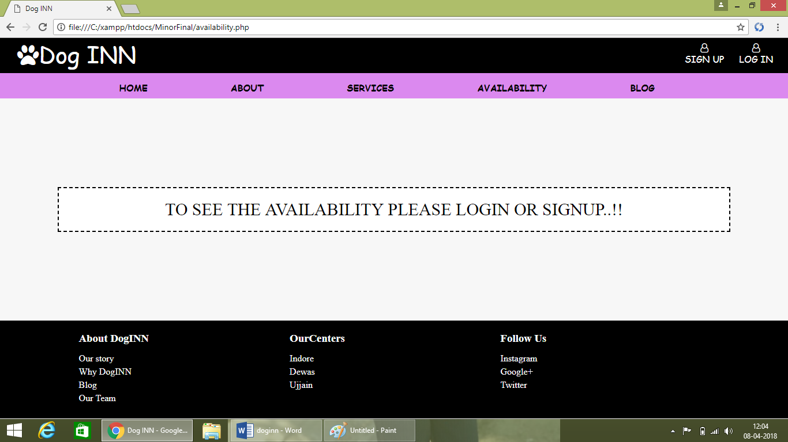

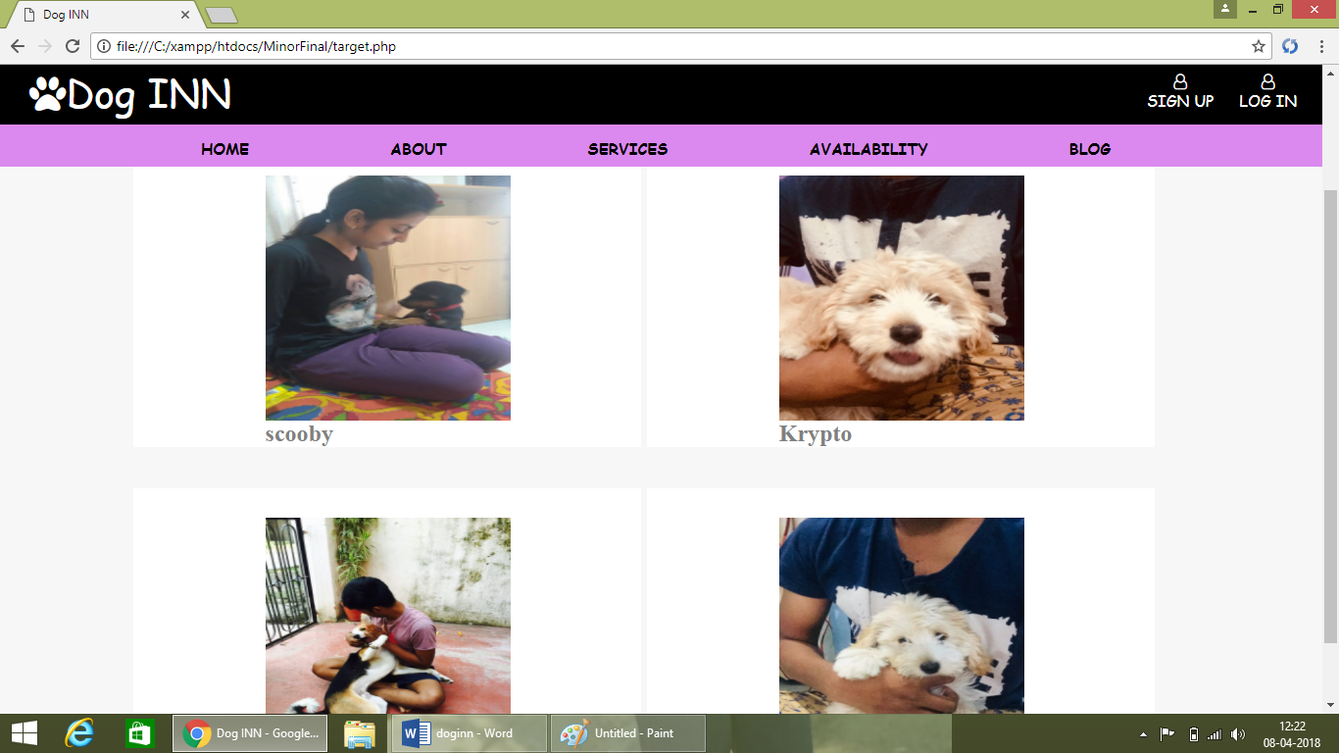

**Blog page**

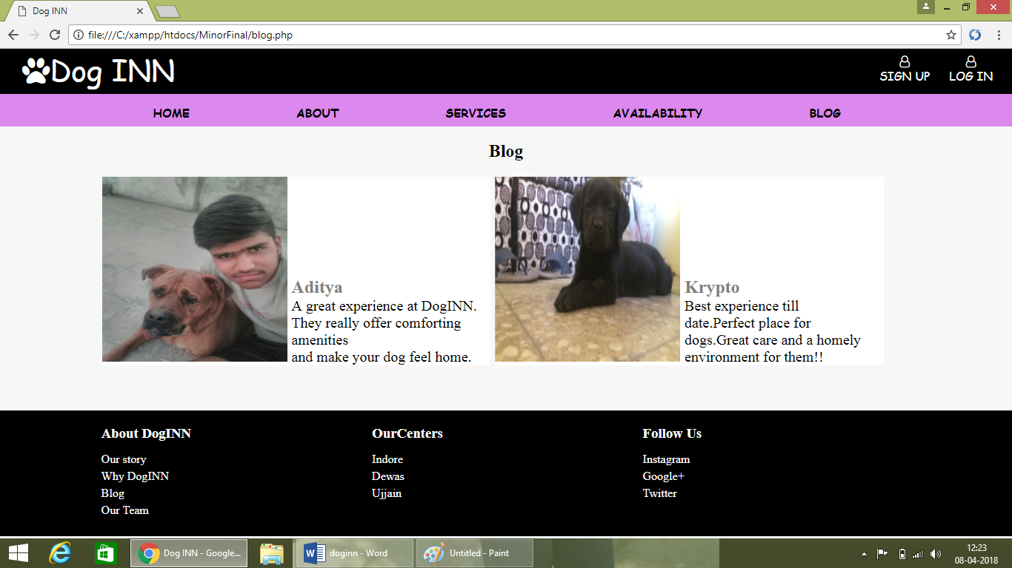

**Our Story Page**

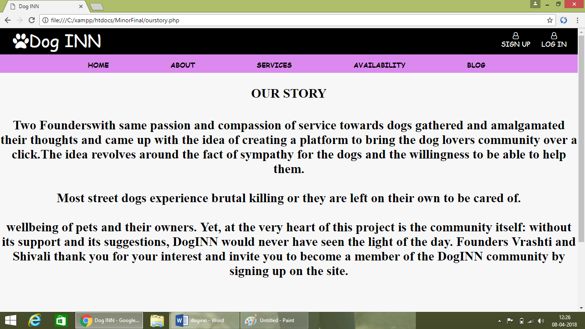

**Sign Up Page**

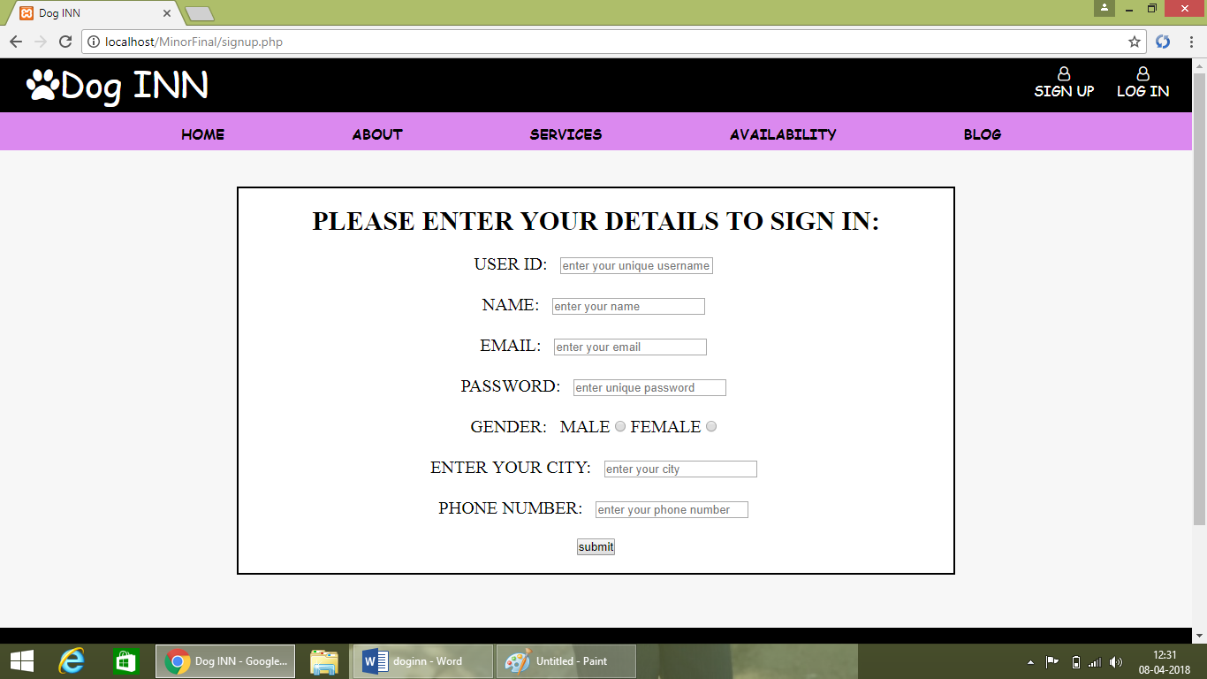

**Login Page**

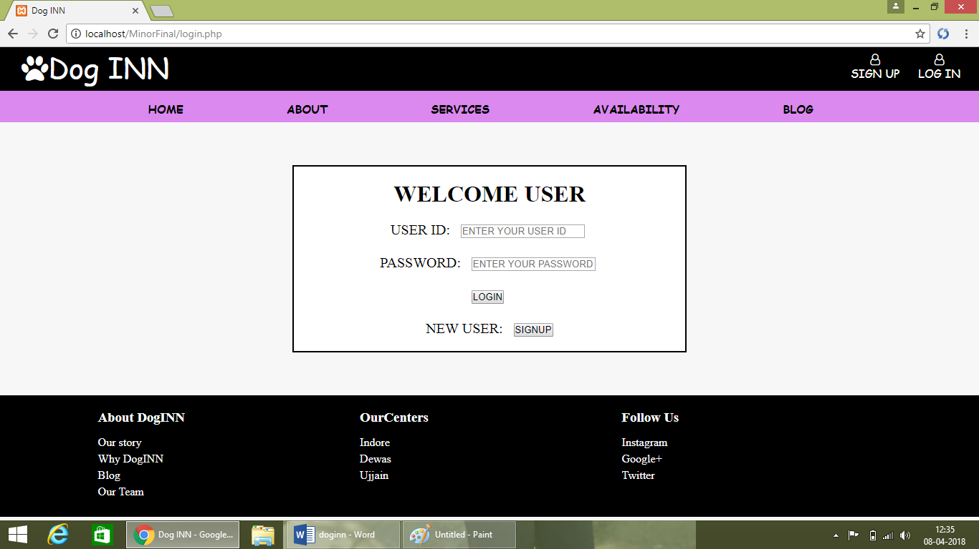

**Testing**

**Implementation Approaches**

The software design description document has been used as input in the implementation process . The actual implementation of the system has been done using php, which is a server sude scripting language. Php has been used to interact with the backend database. In this impliementation , Msaccess has been used as the backend rdbms . php processes the inputs or commands given by the user and translates them in the commands understandable to the backnd database. The output produced by the backend database are alos handled by php, which then genrates html code in real time and formats the output produced by mysql in html format, which can be displayed by the browser macintosh and linux , this portal can be implemented in a truly plateform independent manner . since both these technologies are open source and free and have a large user community , the development cost of portal using msaccess is very low.

**Testing Approach**

A modular approach has been adopted in developing the portal. Thus the two modules of portal have been developed separately and integrated with each other at a later stage. Unit testing, integration testing and system testing have been carried out as per the test cases debugged on these modules

**unit testing**

**Test case 1**

|  |  |  |  |  |
| --- | --- | --- | --- | --- |
| **Test Data:** | **USER Name = “admin” and PASSWORD = “admin”** |  |  |  |
|  | | | | |
| **Step No:** | **Steps** | **Data** | **Expected Result** | **Actual Result** |
| **1** | **Test Case No: 001** | **User Name= admin** | **Should Display Warning Message Box "Please Enter User name and Password"** | **Warning Message** |
| **2** | **Enter Password and press LOGIN Button** | **Password=admin** | **Should Display Warning Message Box "Please Enter User name and Password"** | **Warning Message** |
| **3** | **Enter user Name and Password and press LOGIN Button** | **User Name=”rtsasidharan”**  **Passw=”lol”** | **Should Display Warning Message box”Incorrect Username and Passowrd** | **Warning Message** |
| **4** | **Enter User Name and password and press Login Button** | **User Name=”admin” Password=”admin”** | **Should display Main Screen** | **Navigated to Main Screen** |

**Test Case 2**

|  |  |  |  |  |
| --- | --- | --- | --- | --- |
| **Test Case No: 002** | | | | |
| **Test Data:** |  |  |  |  |
|  | | | | |
| **Step No:** | **Steps** | **Data** | **Expected Result** | **Actual Result** |
| **1** | **Type the link on the address bar and hit enter** | **Address of the Page** | **Should Display the Home Page** | **Error Message “Server Error”** |
| **2** | **Fixed the Server error & Type the link on the address bar and hit enter** | **Address of the Page** | **Should Display the Home Page** | **Home Page Displayed without necessary Graphics** |
| **3** | **Fixed the Bug &Type the link on the address bar and hit enter** | **Address of the Page** | **Should Display the Home Page** | **Home page Displayed without any issues** |

**Limitation:**

1. Availability of internet connection is compulsory.

2: The images of the Recipes is not provided by us.

3. For Data base we use ‘phpmyadmin’ which creates problems in some environment.

**Future Enhancement:**

The performance of the system is proved to be efficient. All the Profiles receive an overall benefit through the system. The system provides flexibility for incorporating new features, which may be necessary in future.

**Conclusion:**

We are confident that our website will help in guiding every human being who love dogs and it will be good for the homeless dog to find the home where they will be taken care and will be provided with food and love and affection from the owner.

**BIBLIOGRAPHY**

* **www.pawshake.com**
* **www.rover.com**
* **w3 schools**
* **PHP and MYSQL Web Development by Luke Welling & Laura Thompson.**
* **Web technologies textbook by Uttam K. Roy.**